
Job Hazard Analysis Informational Document

Why a job hazard analysis is important:

Throughout the United States many workers are injured and killed at the workplace. Workplace injuries and illnesses can be prevented by looking at the workplace operations, establishing proper job procedures, and ensuring that all employees are trained properly.

One of the best ways to determine and establish proper work procedures is to conduct a job hazard analysis. Supervisors can use the findings of a job hazard analysis to eliminate and prevent hazards in the workplace, which is likely to result in fewer worker injuries and illnesses; safer, more effective work methods; and increased productivity.

What jobs are appropriate for a job hazard analysis:

Analysis should go to the following types of jobs throughout the workplace:
- Jobs with the highest injury or illness rates.
- Jobs with the potential to cause severe or disabling injuries or illness even if there is no history of previous accidents.
- Jobs in which simple human error could lead to a severe accident or injury.
- Jobs that are new to the operation or have undergone changes in processes and procedures.
- Jobs complex enough to require written instruction.

To perform a job hazard analysis, you would ask:
- What can go wrong?
- What are the consequences?
- How could it happen?
- What are other contributing factors?
- How likely is it that the hazard identified will occur?

Involve faculty and staff in the process to ensure a comprehensive review of each identified task.

How to mitigate identified hazards:

Controls: This is how to eliminate or minimize the hazards. There are three types of controls.
- Engineering Controls
- Designing the facility, equipment, or process to remove the hazard.
- Substituting processes, equipment, materials, or other factors to lessen the hazard.
- Enclosure of the hazard using enclosed cabs, enclosures for noisy equipment, or other means.
- Isolation of the hazard with interlocks, machine guards, blast shields, welding curtains, or other means.
- Removal or redirection of the hazard such as with local exhaust ventilation.
- Administrative Controls
- Written operating procedures, work permits, and safe work practices.
- Exposure time limitations.
- Monitoring the use of highly hazardous materials.
- Alarms, signs, and warning.
- Buddy system.
- Training.
- Personal Protective Equipment
- When engineering controls are not feasible or do not totally eliminate the hazard.
- While engineering controls are being developed.
- When safe work practices do not provide sufficient additional protection.
- During emergencies when engineering controls may not be feasible.

Hazard Analysis and Equipment Selection Compliance Requirements
OSHA 29 CFR 1910.132 clarifies the following:

The employer will assess the workplace to determine if hazards are present, or are likely to be present, which necessitate the use of personal protective equipment (PPE). If such hazards are present, or likely to be present, the employer shall:
- Select, and have each affected employee use, the types of PPE that will protect them from the hazards identified in the assessment.
- Communicate selection decisions to each affected employee.
- Select PPE that properly fits each affected employee.

The employer shall verify that the required workplace hazard assessment has been performed through a written certification that identifies the workplace evaluated; the person certifying that the evaluation has been performed; the date(s) of the hazard assessment; and, identifies the document as a certification of hazard assessment.

The employer shall provide training to each employee on the administrative controls and the use of the required PPE.

PPE used to comply per standard shall be provided by the employer at no cost to the employees.

Contact the Campus Safety Manager for assistance with Job Hazard Analysis.

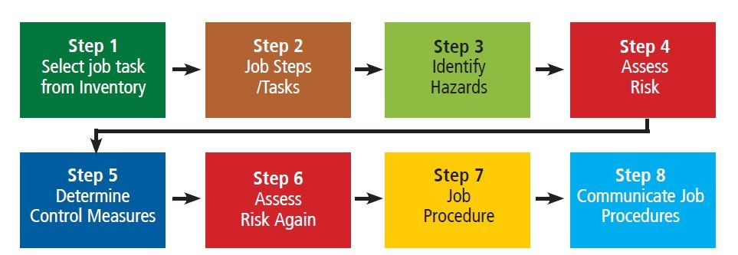

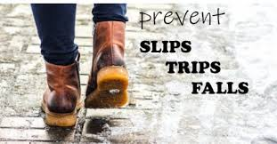



Common Hazard Examples and Descriptions
Chemical (Toxic)
A chemical that exposes a person by absorption through the skin, inhalation, or through the blood stream that causes illness, disease, or death.

Chemical (Flammable)
A chemical that, when exposed to a heat ignition source, results in combustion. Typically, the lower a chemical’s flash point and boiling point, the more flammable the chemical.

Chemical (Corrosive)
A chemical that, when it comes into contact with skin, metal, or other materials, damages the materials. Acids and bases are examples of corrosives.

Explosion (Chemical Reaction)
Self-explanatory.

Explosion (Over Pressurization)
Sudden and violent release of a large amount of gas/energy due to a significant pressure difference such as a rupture in a boiler or compressed gas cylinder.

Electrical (Shock / Short Circuit)
Contact with exposed conductors or a device that is incorrectly or inadvertently grounded, such as when a metal ladder comes into contact with power lines.
Electrical (Fire)
Use of electrical power that results in electrical overheating or arcing to the point of combustion or ignition of flammables, or electrical component damage.

Electrical (Static / ESD)
The moving or rubbing of wool, nylon, other synthetic fibers, and even flowing liquids can generate static electricity. This creates an excess or deficiency of electrons on the surface of material that discharges (spark) to the ground resulting in the ignition of flammables or damage to electronics or the body’s nervous system.

Electrical (Loss of Power)
Safety-critical equipment failure as a result of loss of power.

Ergonomics (Strain)
Damage of tissue due to overexertion (strains and sprains) or repetitive motion.

Excavation (Collapse)
Soil collapse in a trench or excavation as a result of improper or inadequate shoring. Soil type is critical in determining the hazard likelihood.

Fall (Slip / Trip)
Conditions that result in falls (impacts) from height or traditional walking surfaces (such as slippery floors, poor housekeeping, uneven walking surfaces, exposed ledges, etc.).

Fire / Heat
Temperatures that can cause burns to the skin or damage to other organs. Fires require a heat source, fuel, and oxygen.

Mechanical / Vibration
Vibration can cause damage to nerve endings, or material fatigue that results in a safety-critical failure. (Examples are abraded slings and ropes, weakened hoses and belts.)

Mechanical Failure
Typically occurs when devices exceed designed capacity or are inadequately maintained.

Mechanical
Skin, muscle, or body part exposed to crushing, caught-between, cutting, tearing, shearing items or equipment.

Noise
Noise levels (>85 dBA 8 hr. TWA) that result in hearing damage or inability to communicate safety critical information.

Radiation (Ionizing)
Alpha, Beta, Gamma, neutral particles, and X-rays that cause injury (tissue damage) by ionization of cellular components.

Radiation (Non-Ionizing)
Ultraviolet, visible light, infrared, and microwaves that cause injury to tissue by thermal or photochemical means.

Struck By (Mass Acceleration)
Accelerated mass that strikes the body causing injury or death. (Examples are falling objects and projectiles.)

Struck Against
Injury to a body part as a result of coming into contact of a surface in which action was initiated by the person. (An example is when a screwdriver slips causing injury.)

Temperature Extreme (Heat / Cold)
Temperatures that result in heat stress, exhaustion, or metabolic slow down such as hypothermia.

Visibility
Lack of lighting or obstructed vision that results in an error or other hazard.

Weather Phenomena (Snow / Rain / Wind / Ice)
Self-explanatory.

Job Hazard Analysis Form

- All items identified on this form need to be clarified so an effective mitigation strategy can be documented and developed.

- Use a separate form for each hazard identified.

- The safety and health of university faculty, staff, and students is priority #1.

Job Location:

Analyst:

Date:

Task Description:

Hazard Description:

Hazard Controls:

Sample Job Hazard Analysis Process
Form Filled Out

Note: This location had several hazards identified in need of attention.

Job Location: Metal Shop Item #1

Analyst: Joe Safety Bear

Date: February 18, 2025

Task Description: Worker reaches into metal box to the right of the machine, grasps a 15-lb casting and carries it to the grinding wheel. Worker grinds 20 to 30 castings per hour.

Hazard Description: Picking up a casting, the employee could drop it onto his foot. The casting’s weight and height could seriously injure the worker’s foot or toes.

Hazard Controls:
- Remove castings from the box and place them on a table next to the grinder.

- Wear steel-toe shoes with arch protection.

- Change protective gloves that allow a better grip.

- Use a device to pick-up the castings.

- Train workers in proper lifting techniques and PPE use.

Job Location: Metal Shop Item #2

Analyst: Joe Safety Bear

Date: February 18, 2025

Task Description: Worker reaches into metal box to the right of the machine, grasps a 15-lb casting and carries it to the grinding wheel. Worker grinds 20 to 30 castings per hour.

Hazard Description: Castings have sharp burrs and edges that can cause severe lacerations.

Hazard Controls:
- Use a device such as a clamp to pick up the castings.

- Wear cut-resistant gloves that allow a good grip and fit tightly to minimize the chance that they will get caught in grinding wheel.
________________________________________________________________

Job Location: Metal Shop Item #3

Analyst: Joe Safety Bear

Date: February 18, 2025

Task Description: Worker reaches into metal box to the right of the machine, grasps a 15-lb casting and carries it to the grinding wheel. Worker grinds 20 to 30 castings per hour.

Hazard Description: Reaching, twisting, and lifting 13-lb castings from the floor could result in a muscle strain to the lower back.

Hazard Controls:
- Move the castings from the ground and place them closer to the work zone to minimize lifting.

- Train workers not to twist while lifting and reconfigure workstations to minimize twisting during lifts.

