
ENVIRONMENTAL HEALTH & SAFETY DEPARTMENT
HOT WORK PROGRAM

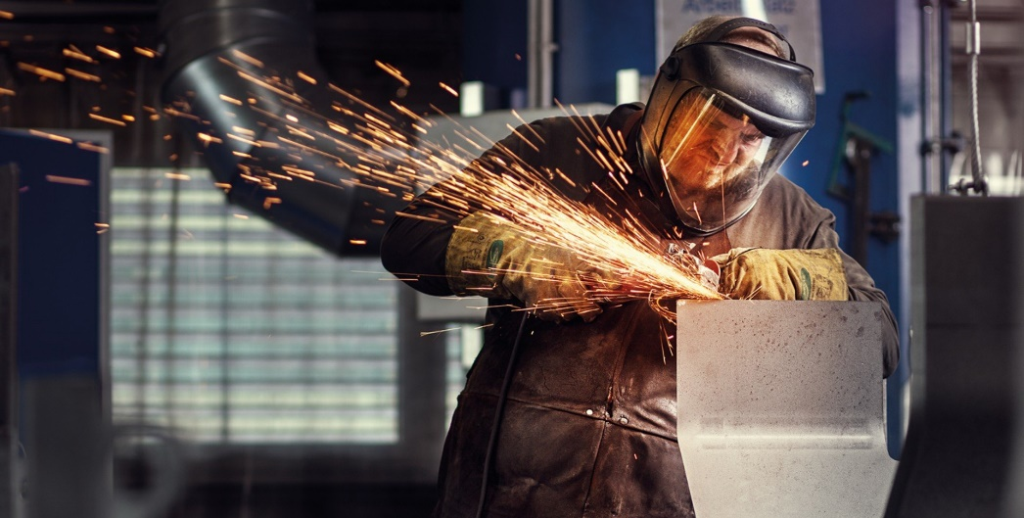

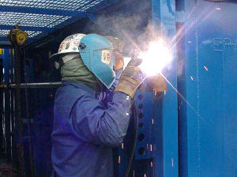

United States Department of Labor
Occupational Safety & Health Administration
29 CFR 1910.252 – Welding, Cutting, and Brazing

National Fire Protection Association (NFPA)
Standard 51B – Fire Prevention during Welding, Cutting, and Other Hot Work

Contractor Requirements
To Perform HOT WORK at Baylor University
* (Make sure you can meet these requirements before starting work.) *

- Hot Work conducted will be in conformance with OSHA, NFPA 51B, and the University Hot Work Program.

- All OSHA mandated training for work must be completed by the contractor prior to work beginning. (Hot Work, Fire Watch, Fire Safety, Fire Extinguisher, HAZCOM, PPE, etc.) The required training is the responsibility of the contractor. The University EHS Campus Safety Manager and/or designee may request training records to verify compliance.

- Contractor’s “Competent Person” will assess the site and ensure all necessary steps of this program are fully carried out. An OSHA “competent person” is defined as “one who is capable of identifying existing and predictable hazards in the surroundings, or working conditions which are unsanitary, hazardous, or dangerous to employees, and who has authorization to take prompt corrective measures to eliminate them” (29 CFR 1926.32(f)).

- Contractor needs to be able to text, receive/send e-mails, take pictures, download, and send pictures of the worksite to the EHS Campus Safety Manager and/or designee.

Contractor must take digital pictures of the hot work site to upload to the electronic permit prior to submission. Photographs must be descriptive of the surrounding areas adjacent to where the Hot Work is to take place. Hot Work Permit request and pictures should be submitted prior to when work is scheduled to start. Emergency Hot Work Permits can be requested by calling or texting the Campus Safety Manager for approval. Texting is the most efficient and timely method.

- The HOT WORK PERMIT form is to be filled out, and all criteria fulfilled for approval consideration. Upon approval the permit is to be posted on the jobsite. A HOT WORK PERMIT is good for only one shift, unless approval for multiple shifts at the same site have been prearranged with the Campus Safety Manager. If the job is going to take several days/shifts permits must be completed, approved, and posted for each.

- Failure to follow permit requirements will result in work stoppage until compliance demonstrated.

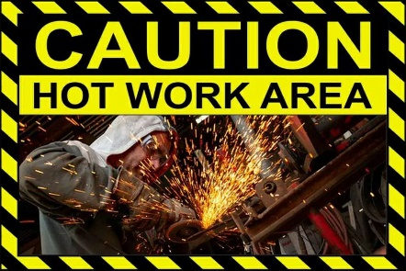
Hot Work Program

Program Statement
This program establishes a permit authorization system to ensure all hazards are evaluated and appropriate safety measures and controls are taken prior to and during any hot work operation that uses an open-flame or spark-producing apparatus.
Best practice information located in the Occupational Safety & Health Administration’s (OSHA) workplace standard, 29 CFR 1910 General Industry Standard, and the National Fire Protection Association (NFPA) code standard 51B, Fire Prevention in Use of Cutting and Welding Processes is always to be fully carried out.
Background

Baylor University recognizes that there is a potential for injury to people and damage to property that can result from fire or sparks that arise when hot work is performed outside of a designated safe hot work area.

Individuals/Entities Affected by this Program

Hot work operating procedures shall apply to Baylor University personnel and contract personnel conducting hot work at, in, and around all university-owned, leased, and/or occupied properties.

Exclusions

This program does not apply to new construction and/or renovations where the university has not taken ownership from the General Contractor.

References

Occupational Safety & Health Administration (OSHA), General Industry Standard
29 CFR Subpart Q – Welding, Cutting and Brazing

National Fire Protection Association (NFPA)
Standard 51B – Fire Prevention During Welding, Cutting, and Other Hot Work

Baylor University HOT WORK PERMIT

Contact

Environmental Health & Safety Department

Campus Safety Manager / 254-709-1991 cell

Definitions

Refer to program reference documents.

Procedures

Refer to program reference documents for clarification of how work is to be performed.

Responsibilities

BU Environmental Health and Safety Department – Campus Safety Manager

- Program development, review, and oversight;
- Training for all university affiliated faculty/staff/ student workers;
- Review submitted Hot Work location photographs and data for Hot Work Permit request approval. Conduct inspection of site if data submitted is not sufficient;
- Evaluate and inspect designated university Hot Work locations on an annual basis or as needed; and
- Hot Work contractor oversight of university owned, leased, and/or occupied properties.

BU Departments, Shops, Laboratories and other entities

These areas are expected to follow the provisions of the Hot Work Program and to ensure that all individuals conducting Hot Work operations have received the required training, Personal Protective Equipment, and oversite needed to work safely.

It is the responsibility of each university department to have designated individuals working in conjunction with the EHS department pertaining to fully carrying out this program.

- Failure to comply with this program will result in work stoppage, or future work postponement.

University Permissible Areas

Routine Hot Work operations is permitted in areas that have been designated as a SAFE HOT WORK AREA:

Baylor Science Building Electronics Shop – D504
Machine Shop – E503

School of Engineering & Computer Science Mechanical Engineering Shop – Rm 100
LaSalle Special Projects Facility
BAJA
Baylor BUILD

BRIC CASPER Center Shop – BRIC 1102 M104

Hooper Schaefer Fine Arts Building Theatre Art Shop – Rm 124
Art Department Shop – Rm 176

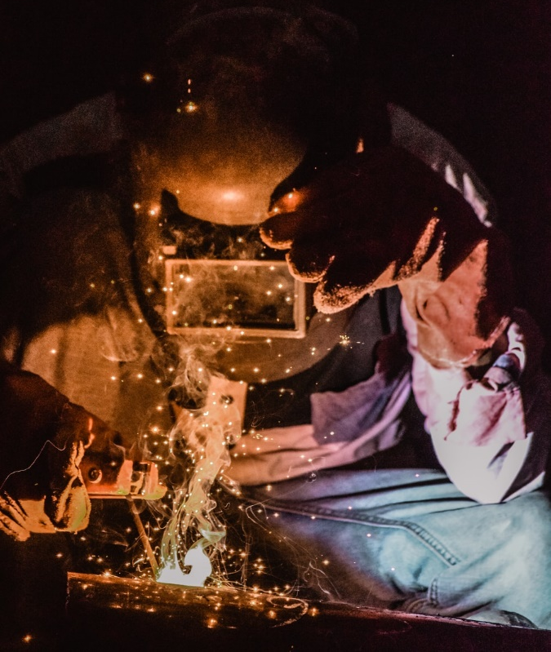
HOT WORK PERMIT
HOT WORK PERMIT
POST AT JOBSITE

Date: _____________Contractor Name: ____________________________________________

Phone: ________________ Specific Hot Work Location: _______________________________

Specific Hot Work Location: ______________________________________________________
(Building Name & Room Number)

Describe Job: __________________________________________________________________
(Brazing, Cutting, Welding, on what specifically)

Person doing HOT WORK: __________________________________Phone: ________________

Name of Person doing Fire Watch: _________________________________________________

Time Fire Watch Began: _______Ended: _______Signature: ____________________________

Are Contractor Employees Trained in all Hot Work Safe Practices: Yes No (Circle One)
(A NO ANSWER WILL RESULT IN PERMIT NOT BEING APPROVED, MUST BE TRAINED)

ANSWER ALL QUESTIONS – CIRCLE APPROPRIATE ANSWER (Y-YES / NA – NOT APPLICABLE)
REQUIRED PRECAUTIONS
Y NA Fire pump in operation/switched to auto. Y NA Water supply control valves for
sprinklers are open.
Y Fire Extinguishers are in service/operable. Y Equipment is in good working order.
REQUIREMENTS WITHIN 35 FEET OF HOT WORK
Y NA Shield combustible construction with Y NA Remove or shield nonremovable
approved welding pads, blankets, curtains. combustibles w/approved items.
Y NA Isolate or remove potential sources of Y NA Shut down ventilation and/or
flammable gas/ignitable liquid/comb. dust. conveying systems.
Y NA Remove combustibles and consider a 2nd fire watch on opposite side of floor, wall,
or roof when openings exist, or thermally conductive materials pass through.
Y NA Is work on a combustible building assembly (e.g., torch applied roofing)?
If yes, provide ADDITIONAL REQUIRED PRECATIONS below.
Hot Work on/in Closed Equipment, Ductwork or Piping
Y NA Isolate equipment from service. Y NA Remove ignitable liquid and purge
Flammable gas/vapor
Y NA Prior to work, and/or during work, monitor Y NA Remove combustible dust/lint or
for flammable gas/vapor. other combustible materials.
Fire Watch/Fire Monitoring the HOT WORK Area
Fire watchers shall have fire extinguishing equipment readily available and be trained in its use.
They shall be familiar with facilities for sounding an alarm in the event of a fire. They shall watch for fires in all exposed areas. A fire watch shall be maintained for at least one hour after completion of welding or cutting operation to detect and extinguish and possible fire.
HOT WORK PERMIT
POST AT JOBSITE

- Fill out Hot Work Permit completely for approval.
If you don’t know all the answers, please get them.
Time Fire Watch Began and Ended section with signature will be filled out at the conclusion of the work.

- Take multiple photographs of the area hot work is to be performed, along with surrounding areas. Be detailed in your photographs.

- Text picture of completed HOT WORK PERMIT request and all photographs to the Campus Safety Manager at 254-709-1991 for approval consideration.

- Hot Work Permit request should be submitted prior to work beginning to ensure getting the necessary approval. Emergency request can be submitted but must be noted as such.

- Permit approval and/or questions will follow initial text in a timely manner. Do not begin work until approval is received, call the above number if you have questions and/or have not heard back.

- A Hot Work Permit is only good for 1 shift, unless specific approval has been given by the Campus Safety Manager. If you are going to be doing work at the same location for multiple shifts/days and the photographs still apply note that on the 1st permit requested. A multi-use approval will be given, however fully filled out permits must be completed for each shift and posted.

If you have any questions, call 254-709-1991.

