Emergency Action Plan
Waco Campus Locations

29 CFR 1910.38
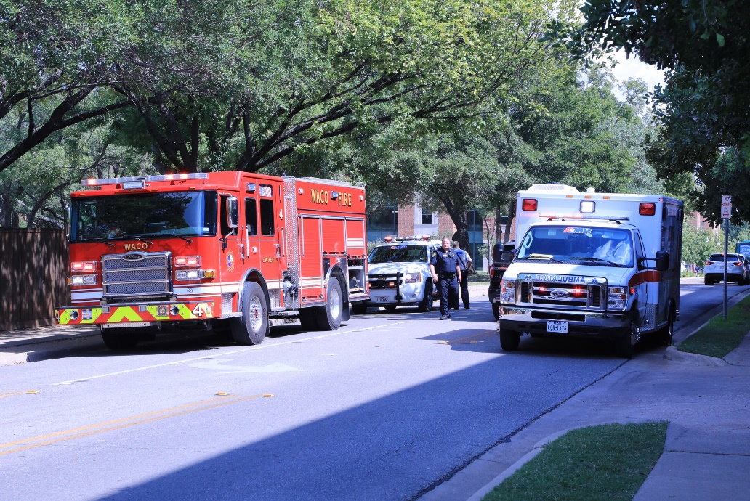

Baylor University is required to have in place an Emergency Action Plan
per OSHA standard 29 CFR 1910.38. The plan must meet all criteria of
the referenced standard. Noted throughout Baylor University’s Emergency Action Plan are references to the standard so that compliance is readily identifiable.

Procedures for Reporting an Emergency

29 CFR 1910.38 (c) (1)

EMERGENCY PHONE NUMBERS

Baylor University Police Department (BUPD): ext. 2222 on campus and (254) 710-2222 from an
off campus phone or cellular phone. Dialing 9-1-1 is always a quick and effective action, notification and getting help on the way is the key.

If the reporting party uses a campus phone, dialing 2222 or 9-1-1 will immediately connect with the BUPD Dispatcher. The BUPD Dispatcher will notify and coordinate any outside services needed for assistance:

- Waco Police Department
- Waco Fire Department
- McLennan County Sheriff’s Office
- Emergency Medical Services

Program the BUPD 2222 and 9-1-1 telephone numbers in your mobile devices to ensure quick access when needed.

BAYLOR CAMPUS GUARDIAN

The Baylor Campus Guardian Mobile Safety Application can turn your smartphone into a personal safety device. You can quickly contact university police in case of an emergency by phone call or text, and you can use the app to dial 9-1-1 when you are off campus.

To Download the free Baylor Campus Guardian App:

- Go to your Apple App Store or google Play Store and search for Rave Guardian;
- As part of the download, you will be asked to create a simple safety profile and enter your Baylor email. It is essential that you provide as much information as possible when setting up your profile; and
- The final step is to reply to an email that will be sent to you by Rave Guardian, this will complete the configuration of the app on your mobile device.

For additional information about the safety app go to the Baylor Department of Public Safety website, go to programs and services, and click on BU Campus Guardian. www.baylor.edu/dps

EVACUATION / SHELTER IN PLACE PROCEDURES

29 CFR 1910.38 (c) (2)

Baylor Alert

Baylor Alert is the University’s system for notifying students, staff, and faculty in the event of a natural disaster, severe weather or other types of emergencies that take place on and around campus. Emergency information and instruction may be sent using one or all the following methods:

- Text message to your cell phone (automatically opted in).
- Audio message to a cell phone or other telephone.
- Email notification to your Baylor email account.
- Outdoor notification system.
- Indoor notification systems.
- Recorded information on the Baylor Information Hotline, (254) 710-4411.
- Designated Baylor websites:
- Faculty & Staff
- Students

- Understand the importance of your role in making this plan work effectively;
- Sign up for the Baylor Alert notification system on the DPS website within the Emergency Management and Fire Safety tab.
- If you receive a Baylor Alert, share the information with others around you of the alert; and

Situational Awareness

- Conduct initial and periodic self-inspection of your work area and surroundings; if you See Something, Say Something – contact the Baylor Police Department or report it on Ethics Point. www.baylor.edu/reportit
- Be aware of the designated emergency evacuation staging and accountability areas located throughout campus (map of designated staging areas located at www.baylor.edu/dps )
- When moving from building to building during the performance of your duties take a few minutes to orient yourself, and be aware of evacuation point(s) in the event an emergency occurs;
- Do not count on others to keep you safe. It is the responsibility of all Baylor faculty / staff to be aware of their surroundings and be prepared to act appropriately if an emergency arises;
- Register to be a recipient of the Baylor Alert emergency notification system referenced above;
- Notify the BUPD if you have any concerns, observe suspicious activity, and/or need to report an event that is/has taken place.

Review your contact information in Bearweb by clicking on “Personal Information”, and “Cell Phone/Emergency Alert Options”.

Evacuation

The movement of persons from a dangerous, or potentially dangerous place, to a safer place.
The tab below will get you to the Baylor Emergency Resources screen. This screen contains the Egress Map, Stop the Bleed and Automatic External Defibrillator (AED) locations, Emergency Call Box locations, and the Evacuation Assembly Points. https://bayloru.maps.arcgis.com/apps/MapSeries/index.html?appid=0197bab3c6834f5595a0dfcc229b8781

- Always evacuate:
- If the alarm sounds.
- If special evacuation announcements are made.
- Authorized/designated faculty/staff building emergency coordinators direct you to evacuate.
- Address any special circumstances that exist within the room/area you are evacuating prior to departure (securing/capping hazardous chemicals, switching off equipment, etc.);
- Close office/classroom doors upon departure;
- While exiting the building be aware and communicate the need to evacuate to anyone not evacuating;
- Do not use elevators during an evacuation;
- Use designated corridors and fire exit stairs that lead to the ground level;
- Aid people not physically able to evacuate via the stairs by assisting them to the nearest stairwell and immediately notify the Baylor Police, Fire Department, and/or the Building Emergency Coordinator the following:
- Name
- Specific location
- Individual details (gender, approximate weight, restrictions such as wheelchair, crutches, etc.)
- Exit the building in an orderly manner and move to the designated Evacuation Assembly Point. Instruct all students/visitors to do the same;
- Follow instructions of emergency response personnel and Baylor’s Building Emergency Coordinators;
- Bring any means to account for those who were occupying the building as well as the means to document who has assembled in the Evacuation Assembly Point(s);
- Do not leave the area prior to being accounted for unless the emergency requires immediate relocation from the area in question; and
- Do not re-enter the building until an “All Clear” announcement is given by emergency response personnel or Building Emergency Coordinators.
Evacuation Assembly Point (EAPs) are the point(s) to which all building occupants should report following a building evacuation and are pre-identified locations; specific incidents may require the EAP to be relocated. A map of all EAP’s is available at the link designated at the beginning of the evacuation section.

Shelter in Place

- Follow reverse evacuation procedures to stay/bring students, faculty, staff, and visitors indoors;
- When the direction by authorities to shelter-in-place has been given, everyone is to begin the protocol below and not be outdoors;
- Locate a room to shelter inside. It should be an interior room, at the lowest level (for severe weather), and without windows or with the least number of windows. Utilize as many rooms as necessary to accommodate the number of people in the building. Shut and lock the door(s);
- Faculty/Staff members will account for those within their areas;
- Monitor the Baylor Alert system for emergency and/or further instructions; and
- Take refuge until an evacuation can be safely initiated or an “all clear” is given.

ACCOUNTING FOR EMPLOYEES AFTER AN EVACUATION

29 CFR 1910.38 (c) (4)

- Assembly at the designated Evacuation Assembly Points (EAPs) as identified on the Building Emergency Plan maps;
- Faculty/Staff/Building Emergency Coordinators will account for those within their areas;
- Make sure that you have been accounted for as an occupant of the building when the emergency evacuation took place; and
- Do not leave the EAP until you have been accounted for.

Do not re-enter the building until an “All Clear” announcement is given by emergency response personnel and/or Building Emergency Coordinators.

SPECIFIC TYPES OF EMERGENCY SITUATIONS

Fire Emergency

- If a fire is discovered/observed pull the nearest fire alarm to evacuate the building;
- When a fire alarm is activated all occupants of the building will evacuate per established evacuation protocol;
- If the fire is small/controllable and a fire extinguisher is readily accessible, and you are trained in the use of the extinguisher, an attempt may be made to extinguish the fire;
- Always activate the fire alarm (you or someone else) before any attempt is made to extinguish the fire;
- Be prepared to use an alternate route if necessary due to the location of the fire emergency;
- Address, if possible, any special circumstances that exist within the room you are evacuating prior to leaving – shut off equipment, close chemicals;
- Close doors and windows as you evacuate;
- Do not use the elevators;
- Keep low as you exit from the building if dense smoke is present within the corridor; and
- Follow instructions of emergency response personnel and/or Building Emergency Coordinators.

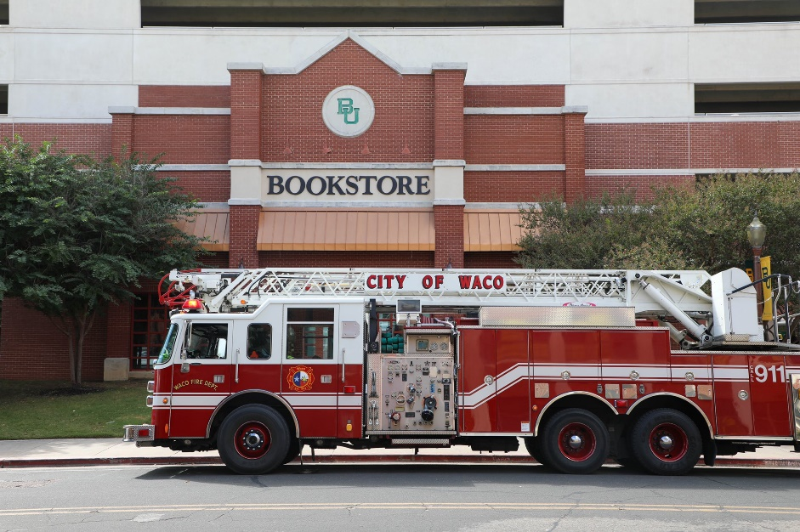

Severe Weather Watch

- Conditions are favorable for severe weather to form, but it does not mean that it is imminent;
- Typical watches will be monitored and changed by ongoing developments;
- Stay alert for weather conditions and announcements; and
- Be prepared to seek shelter.

Severe Weather Warning

- Severe weather is imminent and is based on specific criteria and existing reports received by the National Weather Service;
- Trained meteorologist will monitor the weather by radar and look for areas where there could be high impact damage;
- A warning will be issued when there is evidence of an existing storm and/or a developing tornado;
- National Weather Service verify reports of rotation, storm severity, and storm damage giving meteorologists confidence in what they are seeing on radar;
- Be alert for weather conditions and announcements; and
- Be prepared to seek shelter.

Tornado Watch

- Be Prepared! Tornadoes are possible in and near the watch area;
- Review and discuss emergency plans, and check supplies;
- Be ready to act if a warning is issued or you suspect a tornado is approaching;
- Monitor weather announcements; and
- If you are on an upper floor and the likelihood of a tornado warning being issued exists, consider moving to the lowest level of the building while the elevator can be safely utilized.

Tornado Warning

Take Action – Get Informed!

- A tornado has been sighted or indicated by weather radar;
- City sirens and Baylor Alert will be activated;
- There is imminent danger to life and property if you are in the storm’s path;
- Move to an interior room on the lowest floor of a sturdy building, avoid windows;
- If in a vehicle or outdoors, move to the closest substantial shelter and protect yourself from flying debris; and
- Continue to monitor weather reports / conditions via mobile device, weather radio, etc.

Seeking Shelter during Severe Weather – basic criteria

- Locate a safe inside shelter if possible;
- Move to the lowest level in a building if possible;
- Assist anyone needing special assistance in getting to a designated severe weather assembly area;
- Seek refuge in identified severe weather assembly areas;
- Locate interior rooms within the building on the lowest floors without windows and outside wall exposure (classrooms, restrooms, offices, etc.);
- If in a location where no severe weather assembly area has been previously identified seek locations with criteria identified in this section;
- Avoid single story wide-span roof areas such as auditoriums, gymnasiums, cafeterias, etc. if possible. If located in a structure of this nature stay away from the outside walls and windows;
- Stay calm and follow instructions being communicated through Baylor Alert;
- Use your arms to protect your head and neck;
- Faculty/Staff will account for those within their areas;
- Remain sheltered until the All Clear has been communicated via Baylor Alert, First Responders and/or Building Emergency Coordinators; and
- Report any building damage you observe to Baylor Facility Services at 254-710-1361.

Seeking Shelter – Individuals with Mobility Impairments or Physical Disabilities

- Help will be provided to individuals needing assistance to areas that are being utilized for shelter during an emergency (Building Emergency Coordinators, First Responders, Faculty, Staff, Students);
- Elevators may be used to transport individuals with special needs and their escort(s) to a safer location. The utilization of elevators to move people should be used prior to the weather situation worsening;
- Visually impaired and hearing-impaired individuals may be escorted down the stairs to the designated safe zone. Escorts should stay with the individual(s) to ensure that they can move about as needed and instructed while the emergency is taking place; and
- In the event of a power failure, individuals who are unable to use the stairs and their escorts should move to an interior location without windows and call the Baylor Police at 254-710-2222, who will notify the appropriate emergency personnel with the location.

Flood

If Indoors:
- Be ready to evacuate as instructed by Baylor Alert, designated officials, Building Emergency Coordinators, and/or Emergency Responders;
- Follow evacuation routes (primary/secondary) given at the time the action becomes necessary;
- If evacuation is not an option due to the conditions outside move to higher floors within the structure;
- Notify the Baylor Police Department at 254‐710‐2222 of your location. Create an occupant list so that a record of who in the building is available;
- Remain calm and only relocate when given an All Clear or conditions make remaining at your present location not possible; and
- Keep communications with the Baylor Police Department to ensure accurate and timely information is being disseminated.

If Outdoors:
- Evacuate to a safe area out of the flood zone if time permits;
- Climb to higher ground and stay there until it has been determined safe to relocate; and
- Avoid walking and driving through flood waters.

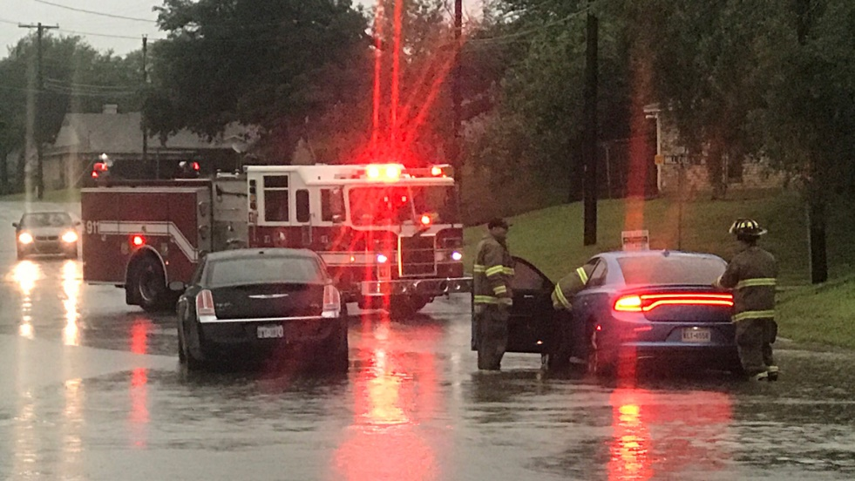
Earthquake

- Stay calm and await instruction from the Baylor Alert or a designated official;
- Keep away from overhead fixtures, windows, unsecured cabinets/shelves/stacked objects, and any other hazard that may pose a threat during the occurrence;
- Assist individuals with special needs in finding a safe place; and
- Evacuate as instructed, or if necessary due to the existing circumstances.

Snow and Ice

The severity and impact that the weeklong winter storm of 2021 had on Texas made everyone aware of the need to be better prepared for that type of weather. Below is a link to the FEMA “How to Prepare for a Winter Storm”.

https://www.ready.gov/sites/default/files/2020-08/fema_winterstorm_htp.pdf

The main cause of injury during snow and ice storms are caused by slips and falls. Below are some things to be aware of and how to mitigate areas of concern:

- Pay close attention to where you are walking;
- Report any unsafe areas to your supervisor;
- If it is unsafe to go outside stay indoors; and
- In the event emergency assistance is required contact the Baylor Police Department.

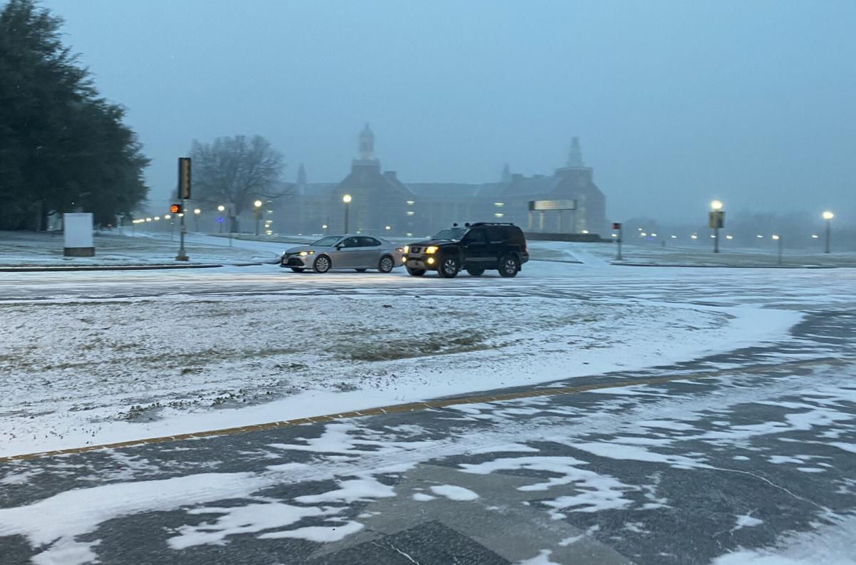

Active Shooter

The Baylor Department of Public Safety “Active Shooter” informational page and training is below. Go to the page, review the material, view the video presentation, and if you have any questions contact the Baylor Police Department as noted on the page.

https://www.baylor.edu/dps/index.php?id=973171

During an act of violence (e.g. robbery, hostage situation, workplace violence, active shooter):

- AVOID - starts with your state of mind;
- Pay attention to your surroundings;
- Have an exit plan; and
- Move away from the source of the threat as quickly as possible. The more distance and barriers between you and the threat, the better.

- DENY - when getting away is difficult or maybe even impossible;
- Keep distance between you and the source;
- Create barriers to prevent or slow down a threat from getting to you;
- Turn the lights off; and
- Remain out of sight and quiet by hiding behind large objects and silence your phone.

- DEFEND - because you have the right to protect yourself;
- If you cannot Avoid or Deny, be prepared to defend yourself;
- Be aggressive and committed to your actions; and
- Do not fight fairly. THIS IS ABOUT SURVIVAL.

CALL 911 or 254-710-2222
When Law Enforcement arrives,
SHOW YOUR HANDS AND FOLLOW COMMANDS.

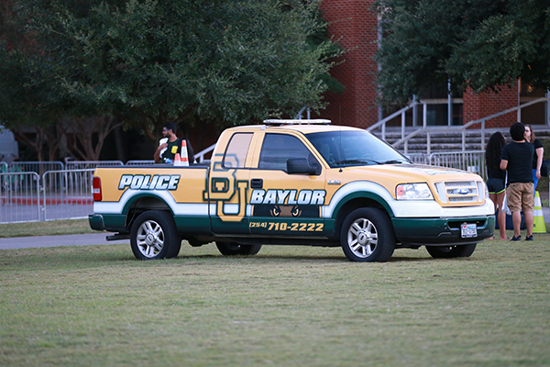

FACULTY / STAFF RESCUE & MEDICAL RESPONSE DUTIES

29 CFR 1910.38 (c) (5)

The Baylor University Police Department along with selected and identified faculty/staff who receive specialized training will follow predetermined protocols setup that only allows exposure to hazards that they have been trained and equipped to mitigate.

FACULTY / STAFF UTILIZED FOR CRITICAL PLANT OPERATION PRIOR TO THEIR EVACUATION

29 CFR 1910.38 (c) (3)

No critical faculty/staff are tasked with working in a position that would require them to not evacuate from their location at the time the evacuation was to take place. Plant operations at Baylor University are staffed and monitored by Baylor Facilities Services, who maintain their own Emergency Action Plan.

FACULTY / STAFF EMERGENCY ACTION PLAN CONTACTS

29 CFR 1910 (c) (6)

Campus Safety Manager 254-710-2492
Senior Director of EHS 254-710-1031
Baylor University Police Department 254-710-2222

FACULTY / STAFF ALARM SYSTEMS

29 CFR 1910.38 (d)

All buildings on the Baylor University campus are equipped with a supervised fire alarm monitoring system, except for the Bobo Spiritual Life facility. In the event a building fire alarm system is activated, speakers and strobes will serve as the warning device notifying occupants of the need to activate.

In addition, Baylor University will utilize Baylor Alert (as described in the Evacuation/Shelter in Place Procedures) to provide warning for necessary action.

FACULTY AND STAFF NOTIFICTION

29 CFR 1910.38 (e)-(f) (3)

All faculty/staff members will be expected to understand and fulfill the Emergency Action Plan that is provided initially, when responsibilities change, when conditions change within the workplace, and when the plan changes.

All faculty/staff members will be expected to complete the following:

- Review the Emergency Action Plan per designated media;
- Questions are to be asked for clarification if required; and
- Self-inspection of working area(s) identifying emergency exit(s), fire extinguisher(s), fire alarm activation pull station(s), etc.

Building Emergency Coordinators serve as an important liaison between occupants of their building(s), the Department of Public Safety, Department of Emergency Management and Emergency Responders. Building Emergency Coordinators have the responsibility for assisting with the coordination of prompt and safe action of staff, faculty, and students in their designated areas during emergencies and drills. The Director of Emergency Management oversees the activities of the Building Emergency Coordinators. These individuals will be selected campus wide among the faculty/staff to receive additional training, equipment, and instructions to assist in carrying out response protocol during the plan activation and training exercises. A list of the Building Emergency Coordinators can be found on the DPS website.

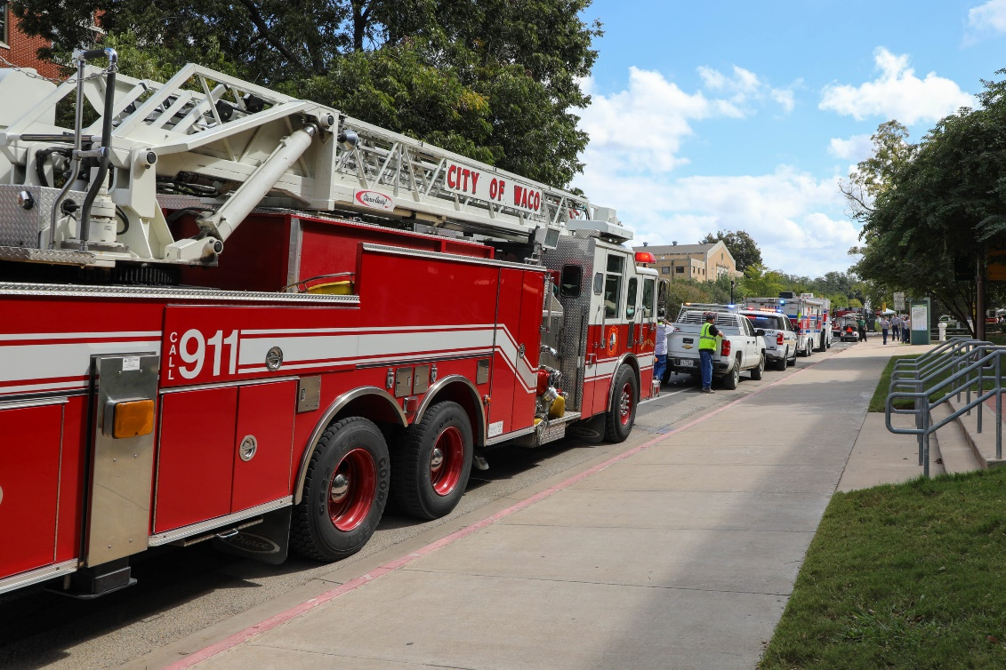

LINKS TO EMERGENCY RESPONSE INFORMATION

Baylor Department of Public Safety
- www.baylor.edu/dps

Occupational Safety and Health Administration
- www.osha.gov

Federal Emergency Management Agency
- www.fema.gov

Department of Homeland Security – Preparedness
- www.ready.gov

